Ideation Phase Empathize & Discover

Date | 23 January 2026
Team ID | LTVIP2026TMIDS64924
Project Name | SmartSorting
Maximum Marks | 4 Marks

Empathy Map Canvas:
An empathy map is a simple, easy-to-digest visual that captures knowledge about a user’s behaviours and attitudes.

It is a useful tool to helps teams better understand their users.
Creating an effective solution requires understanding the true problem and the person who is experiencing it. The exercise of creating the map helps participants consider things from the user’s perspective along with his or her goals and challenges.

Example:
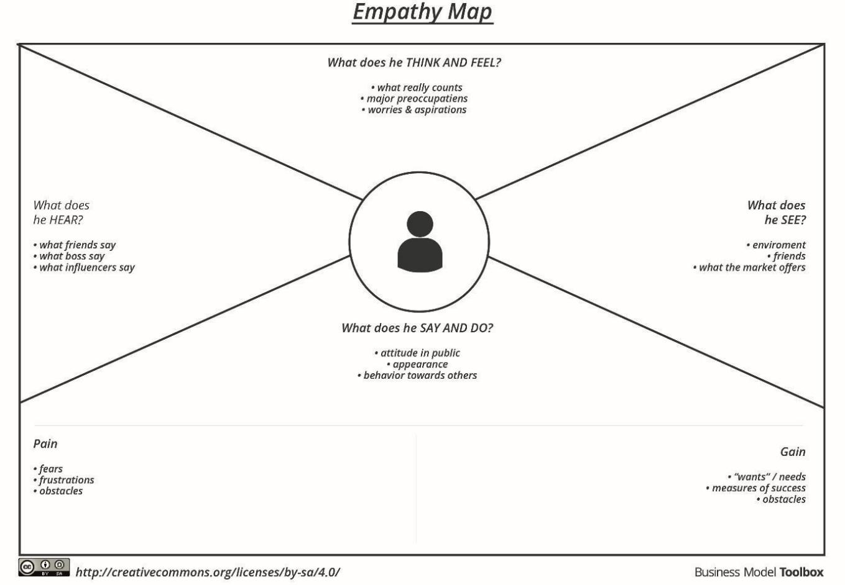

Example: Food Ordering & Delivery Application

🗣️ Says  - “We can't afford expensive AI or technical staff.”  - “Sometimes we miss spoiled fruits, which affects customer trust.”  - “There has to be a better way to do this faster.” | □♂️ Hears  - Customers complaining about receiving spoiled items  - Other vendors talking about AI tools they cannot afford  - Workers expressing frustration and fatigue
🎯 Pains  - High error rate in manual sorting  - Time-consuming process during peak demand  - Financial loss due to unsold or spoiled inventory | ✅ Gains  - A fast, easy-to-use solution to identify rotten produce  - Improved product quality and reduced customer complaints  - Increased trust and brand value through consistent delivery of fresh items
🎯 Pains  - High error rate in manual sorting  - Time-consuming process during peak demand  - Financial loss due to unsold or spoiled inventory | ✅ Gains  - A fast, easy-to-use solution to identify rotten produce  - Improved product quality and reduced customer complaints  - Increased trust and brand value through consistent delivery of fresh items
Example Scenario: Use of SmartSorting in a Small Fruit Industry
Ravi runs a small fruit-sorting business where he and a few workers manually check fruits for freshness. Every day, they receive large quantities of apples, bananas, and tomatoes from local farms. Due to limited time and experience, workers sometimes fail to identify spoiled fruits. As a result, some rotten fruits are packed and sent to shops, leading to customer complaints and product returns.
Ravi wants a simple, low-cost solution to help his team sort fruits more accurately and quickly. With the SmartSorting web app, workers can take a photo of each fruit using a mobile or webcam. The app shows whether the fruit is fresh or rotten instantly. This saves time, reduces mistakes, and helps Ravi improve the quality of his deliveries without needing advanced equipment or training.

